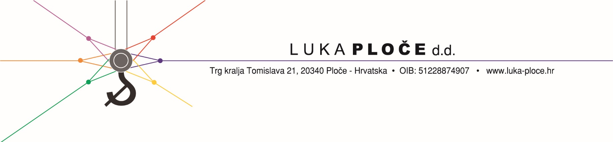

Ordinary share LKPC-R-A ISIN HRLKPCRA0005

Listed at the Official market of the Zagreb Stock Exchange

Notice pursuant to the Croatian Capital Market Act

**HANFA** – Croatian financial

services supervisory Agency

Miramarska cesta 24 b

**HANFA** Official Register of prescribed information

**ZAGREB STOCK EXCHANGE**

Ivana Lučića 2 a, 10000 Zagreb

**HINA – The Croatian news agency**

Ploče, February 14th 2019.

Subject: Notification pursuant to the article 472. of the Capital Market Act

Luka Ploče d.d. with registered office in Ploče,Trg kralja Tomislava 21, OIB (Personal Identification Number) 51228874907 (hereinafter: the Company), pursuant to the Article 472. of the Capital Market Act, hereby notifies that on February 14th 2019. it has received the notification from company ENERGIJA NATURALIS l.l.c. for investment and management, Gospodarska zona 13, Vukovar, OIB (Personal Identification Number): 65900776536 regarding the changes in the percentage of voting rights- exceeding the voting rights threshold within the meaning of Article 482. of the Capital Market Act.

Entire notification received is published in attachment hereto.

Regards,

Luka Ploče d.d.