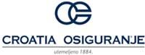

Zagreb Stock Exchange

Zagreb, 20 July 2012

Subject: Correction of the Consolidated business report for the first quarter of 2012

Hereby we inform you that on the Zagreb Stock Exchange is announced a new, corrected version of the financial statements for the first quarter of 2012.

Correction was entered in Consolidated report on Changes in Equity and Consolidated report on Cash flows.

Yours respectfully,

CROATIA osiguranje d.d.

